Project 2.1 - Optimizing Container Images using Multi-Stage Docker Builds

Task 1 - Prepare Golang Application
Create a simple Golang application that can be compiled into a binary.
The application should include basic functionality to simulate a backend service

For this task : I am using GCP VM
Install the go on your system :
Installing with #apt update
#sudo apt install golang-go
Create golang-multistage directory
Create go.mod
#go mod init golang-multistage

Your go.mod will look like:
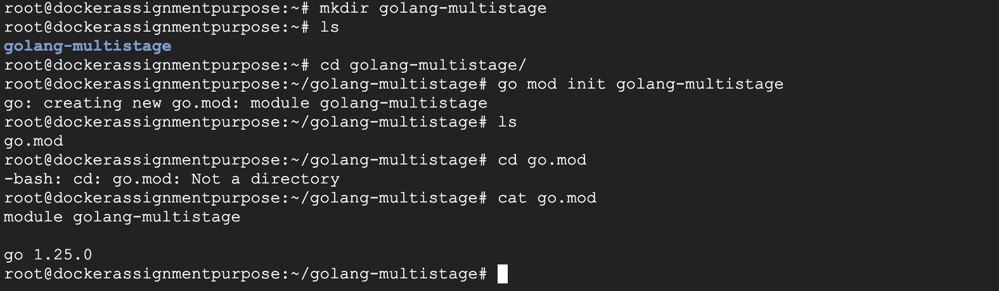

Now create the main.go file :
And run the application :
First check Go: go version
Then run: go run main.go
You should now get:
========================================
Go Backend Application Started
Designed by Snehal for Demo Purpose
Server running on port 8080
========================================
Then open another terminal and test:
#curl http://localhost:8080
Expected: This is application designed by Snehal for Demo Purpose
#curl http://localhost:8080/health
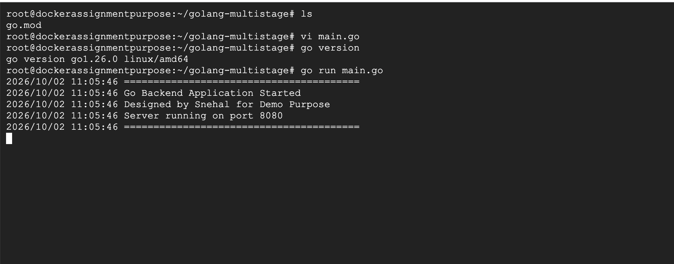
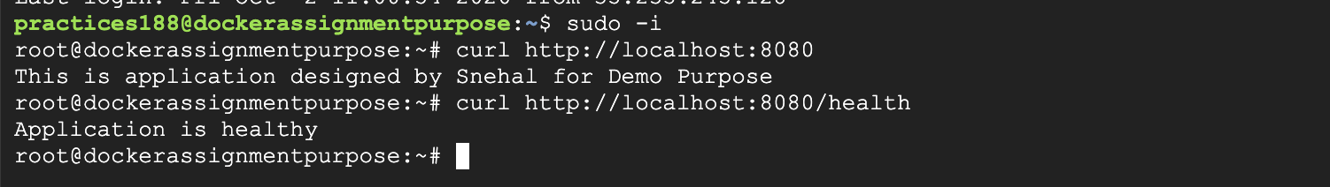

Task 2 - Analyze Traditional Dockerfile
Review a traditional Dockerfile used for building and running a Golang application.
Observe how build dependencies remain inside the final image.

For This let’s create the tradition Dockerfile and build the image and run the container using this image:

From the directory containing main.go, go.mod, and Dockerfile: #docker build -t golang-backend:traditional .
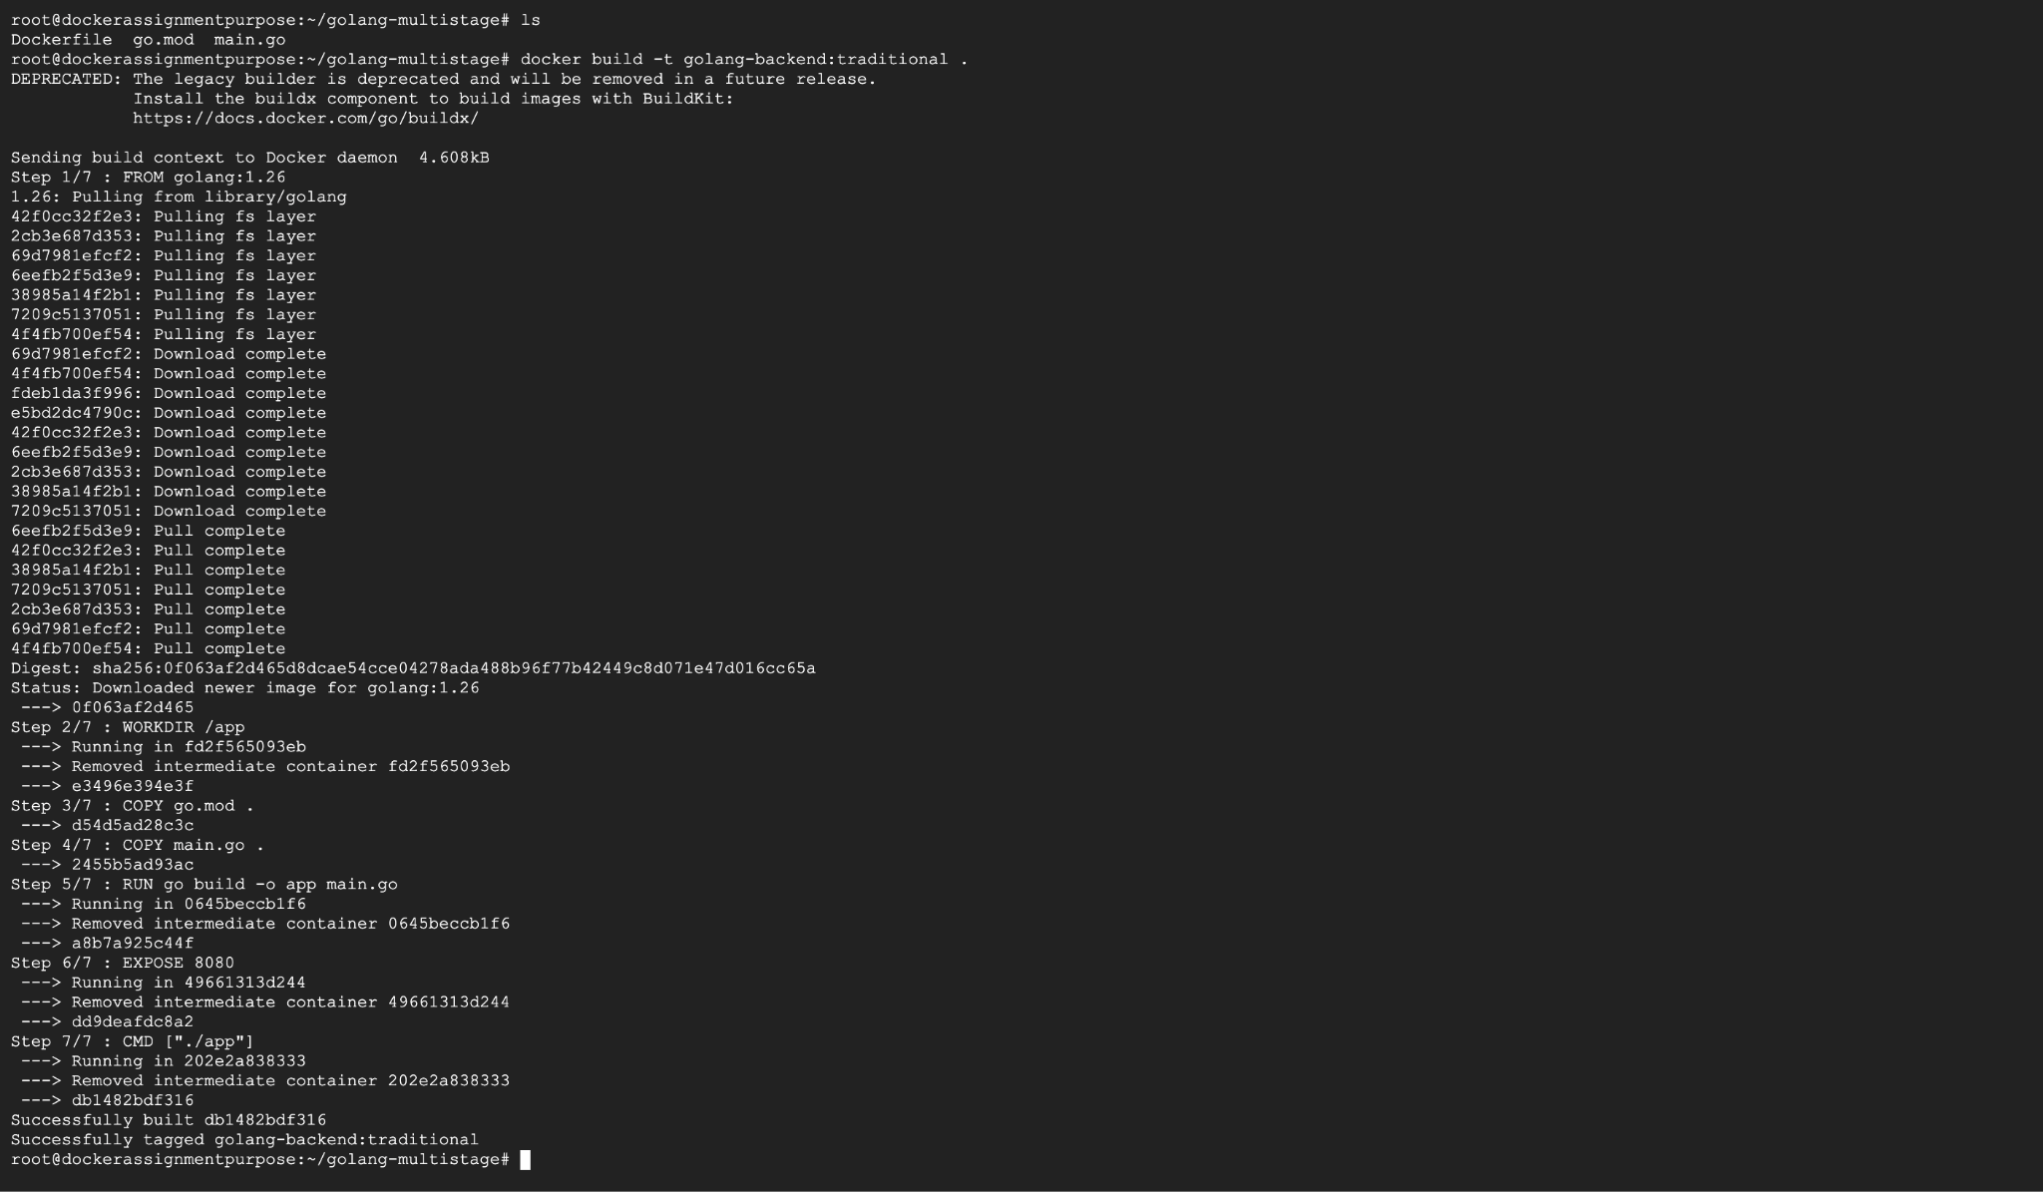

Check the image size :

For Testing run a container :

#docker run -d --name golang-traditional -p 8080:8080 golang-backend:traditional
#docker ps
# docker exec -it a3e0a88b8a2b bash
#curl http://localhost:8080Expected: This is application designed by Snehal for Demo Purpose
#curl http://localhost:8080/health

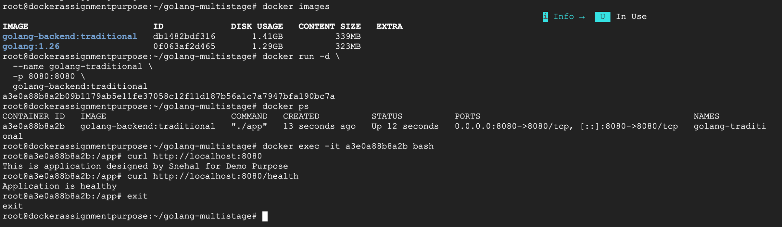

Task 3 - Design Multi-Stage Dockerfile
Create a Dockerfile that includes multiple build stages.
The Dockerfile should contain:
- ﻿﻿A build stage where the application is compiled
- ﻿﻿A runtime stage where the compiled binary is executed
Now Create Dockerfile.multistage.

Task 4 - Build the Multi-Stage Image
Build a Docker image using the multi-stage Dockerfile.
Verify that the build stage successfully compiles the application.
Build the Multi-Stage Image:
#docker build -f Dockerfile.multistage -t golang-backend:multistage .
#docker images

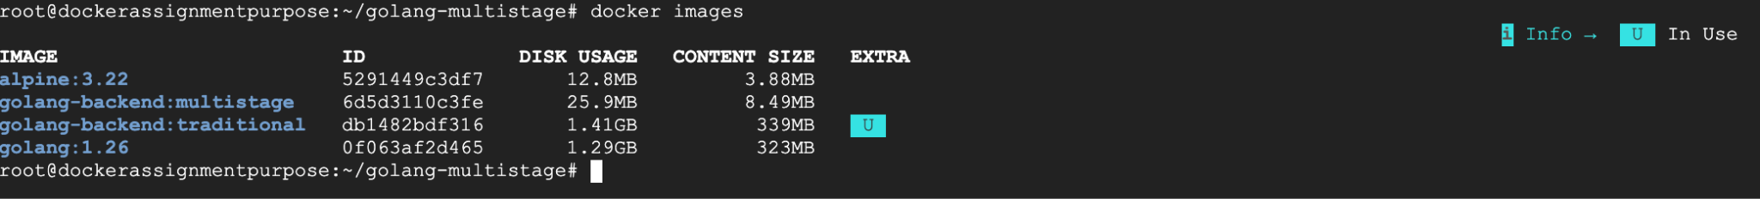
Task 5 - Run Container from Optimized Image
Create and run a container from the optimized Docker image.
Verify that the application runs correctly inside the container.

First stop/remove the traditional container because it is already using port 8080.
#docker rm -f golang-traditional

Now start the multi-stage container:
#docker run -d --name golang-multistage -p 8080:8080 golang-backend:multistage
#docker ps
Error :

Container is exiting check the container logs :

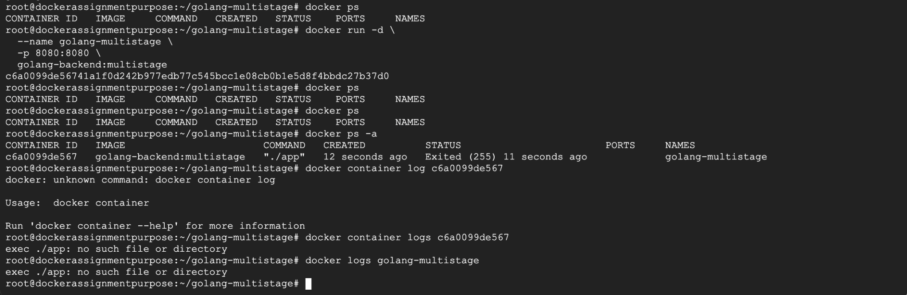

The error is clear:
exec ./app: no such file or directory
The binary exists, but it was built with CGO enabled, so the Alpine runtime doesn't have the required loader/library. This is a common issue when using a Go builder image with an Alpine runtime.
We'll fix it by building a static Go binary with CGO_ENABLED=0.

Update the Dockerfile : The important change is:
RUN CGO_ENABLED=0 GOOS=linux GOARCH=amd64 go build -o app main.go
CGO_ENABLED=0 makes the Go binary statically linked, so it can run inside the lightweight Alpine image without requiring additional libraries.
Remove the old container
#docker rm -f golang-multistage

Rebuild the image : docker build -f Dockerfile.multistage -t golang-backend:multistage .

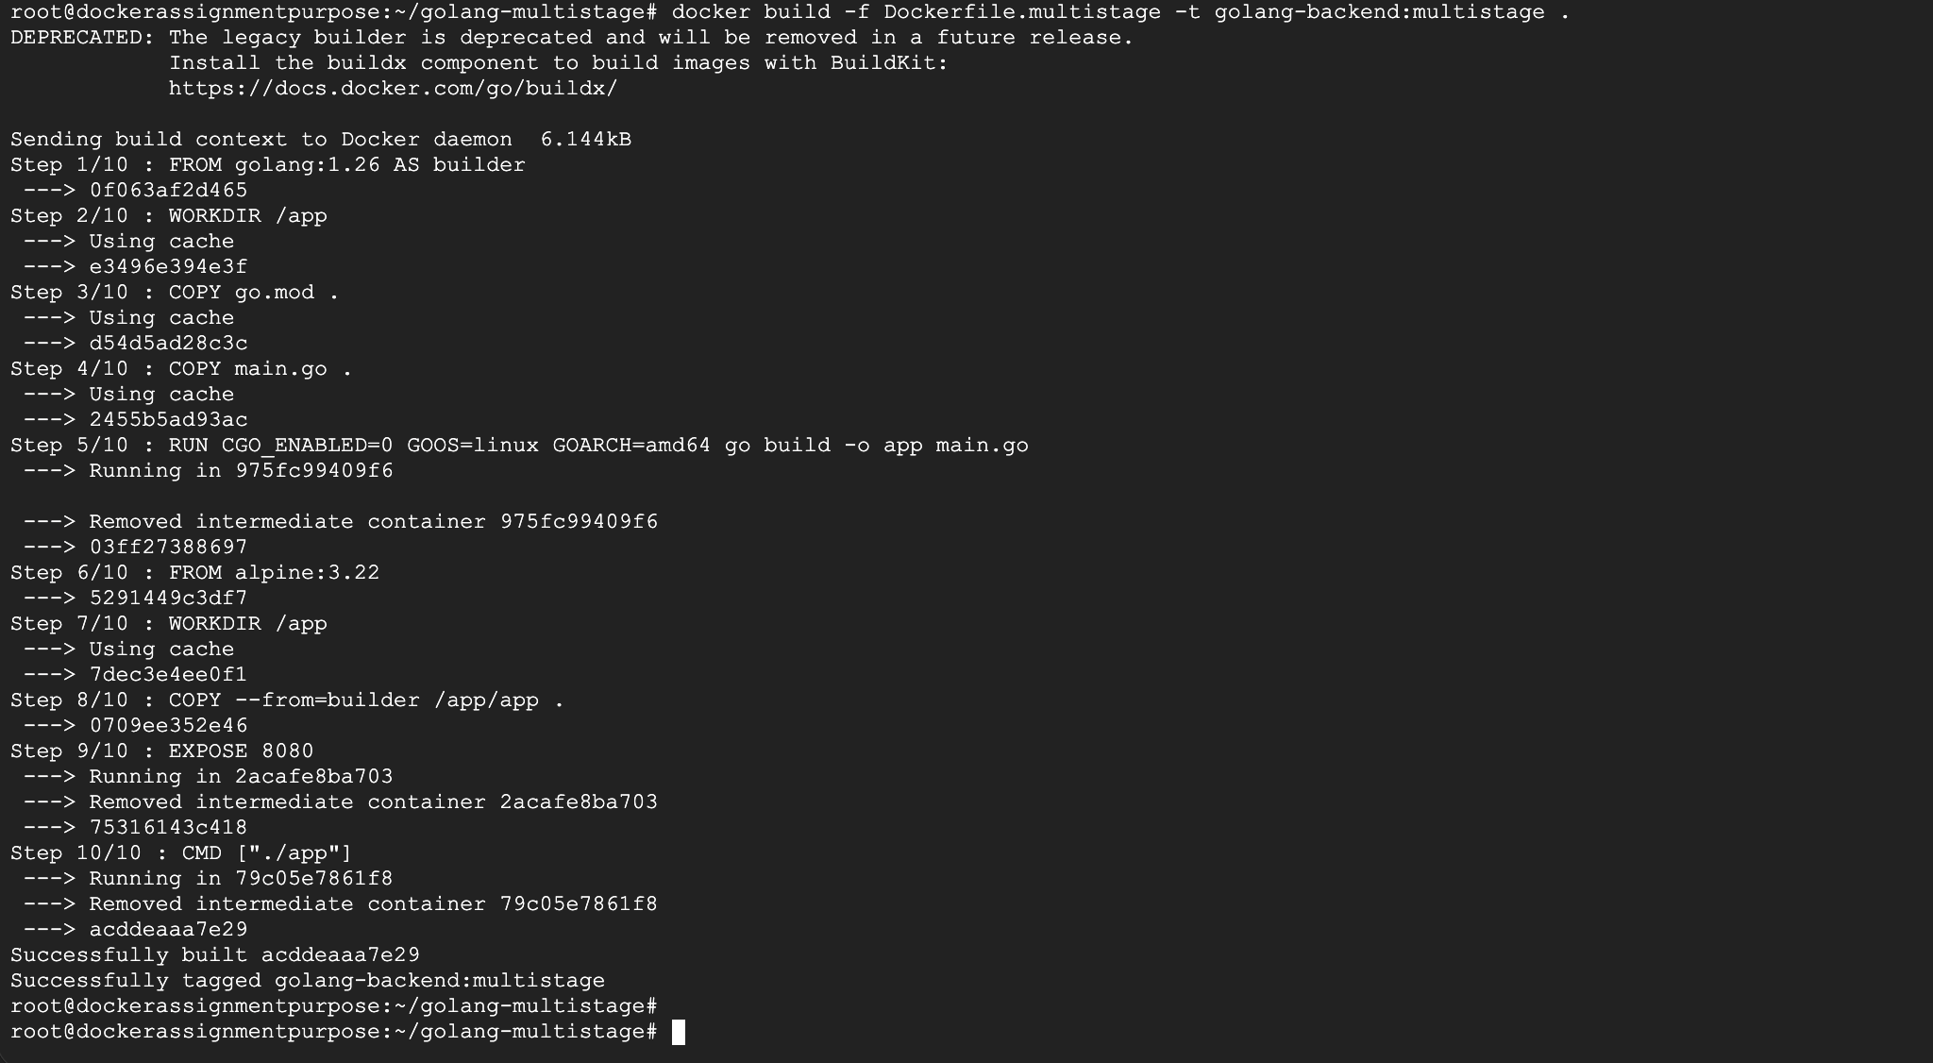
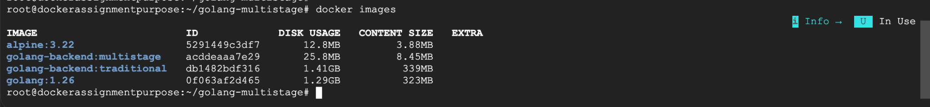
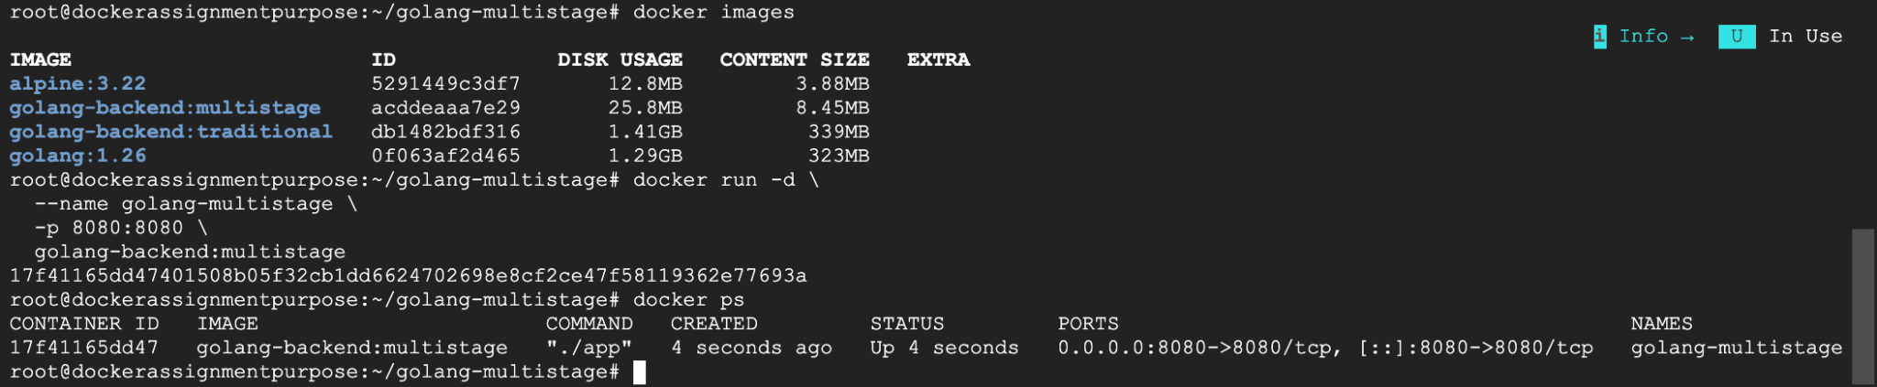

Task 6 - Compare Image Sizes
Compare the image size produced by:
- ﻿﻿Traditional Docker build
- ﻿﻿Multi-stage Docker build
Analyze the improvements in image size and efficiency.
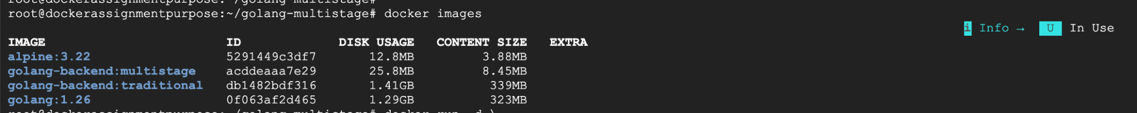

Deliverables
Learners should submit:
﻿﻿Golang application source code. →Ref the Repository
﻿﻿Multi-stage Dockerfile –Ref the repository
﻿﻿Screenshot of built Docker image –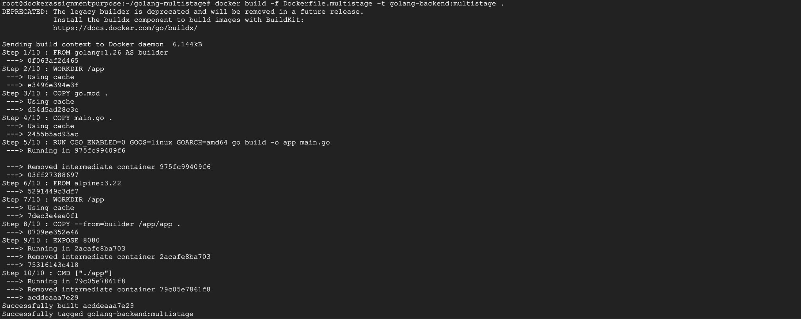
﻿﻿Screenshot of running container
﻿﻿Screenshot comparing image sizes.
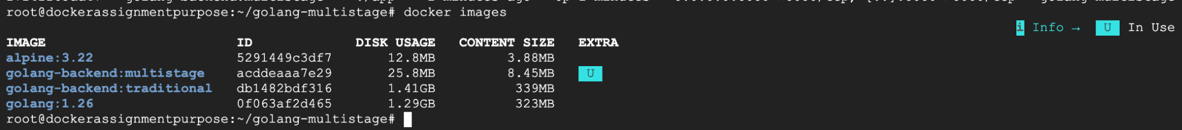
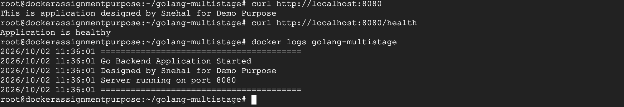

Beyond the Basics - Elevate Exercise

Enhance the container optimization by implementing additional improvements to the Docker image.

Add the following enhancements:

-Use a Minimal Runtime Image :

-Replace the runtime base image with a more minimal image such as Alpine Linux to further reduce the container size and remove unnecessary packages.
For the exercise, we'll use Alpine Linux as the minimal runtime image
-Expose Application Port : expose port 8080.
-Modify the Dockerfile to expose the port used by the Golang application so that the service can be accessed externally.

Created the Dockerfile.optimized with above changes.
Build the image using : docker build -f Dockerfile.optimized -t golang-backend:optimized .

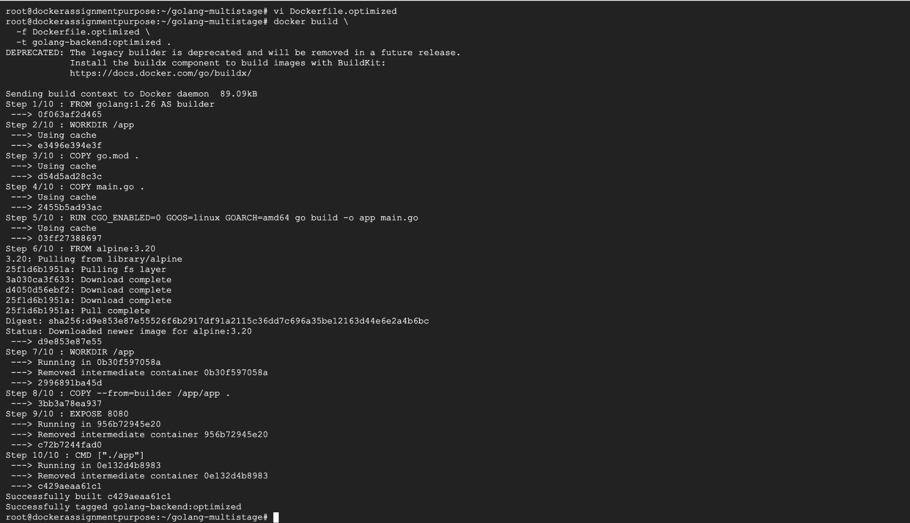

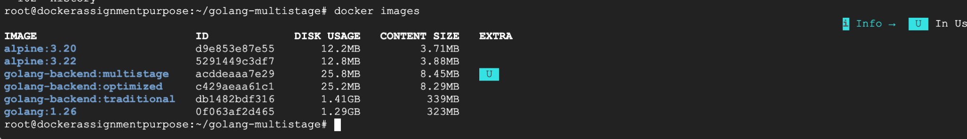

Run the optimized image
First remove the previous container if it exists: #docker rm -f golang-multistage 2>/dev/null
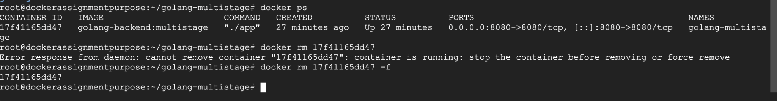
Then: docker run -d –-name golang-optimized -p 8080:8080 golang-backend:optimized
docker run -d \
--name golang-optimized \
-p 8080:8080 \
golang-backend:optimized
Verify:
docker ps
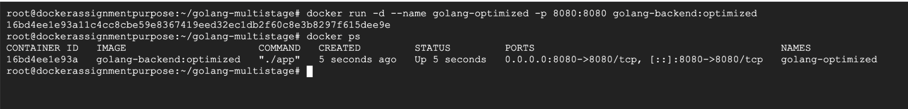
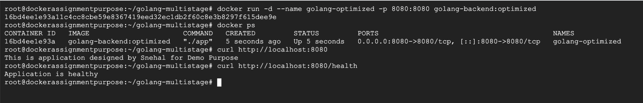

-Push Image to DockerHub

-Tag the optimized Docker image and push it to DockerHub so it can be stored in a container registry and reused for deployments.

#docker tag golang-backend:optimized snehalshinde11/golang-backend:optimized
#docker tag golang-backend:multistage snehalshinde11/golang-backend:multistage
#docker tag golang-backend:traditional snehalshinde11/golang-backend:traditional

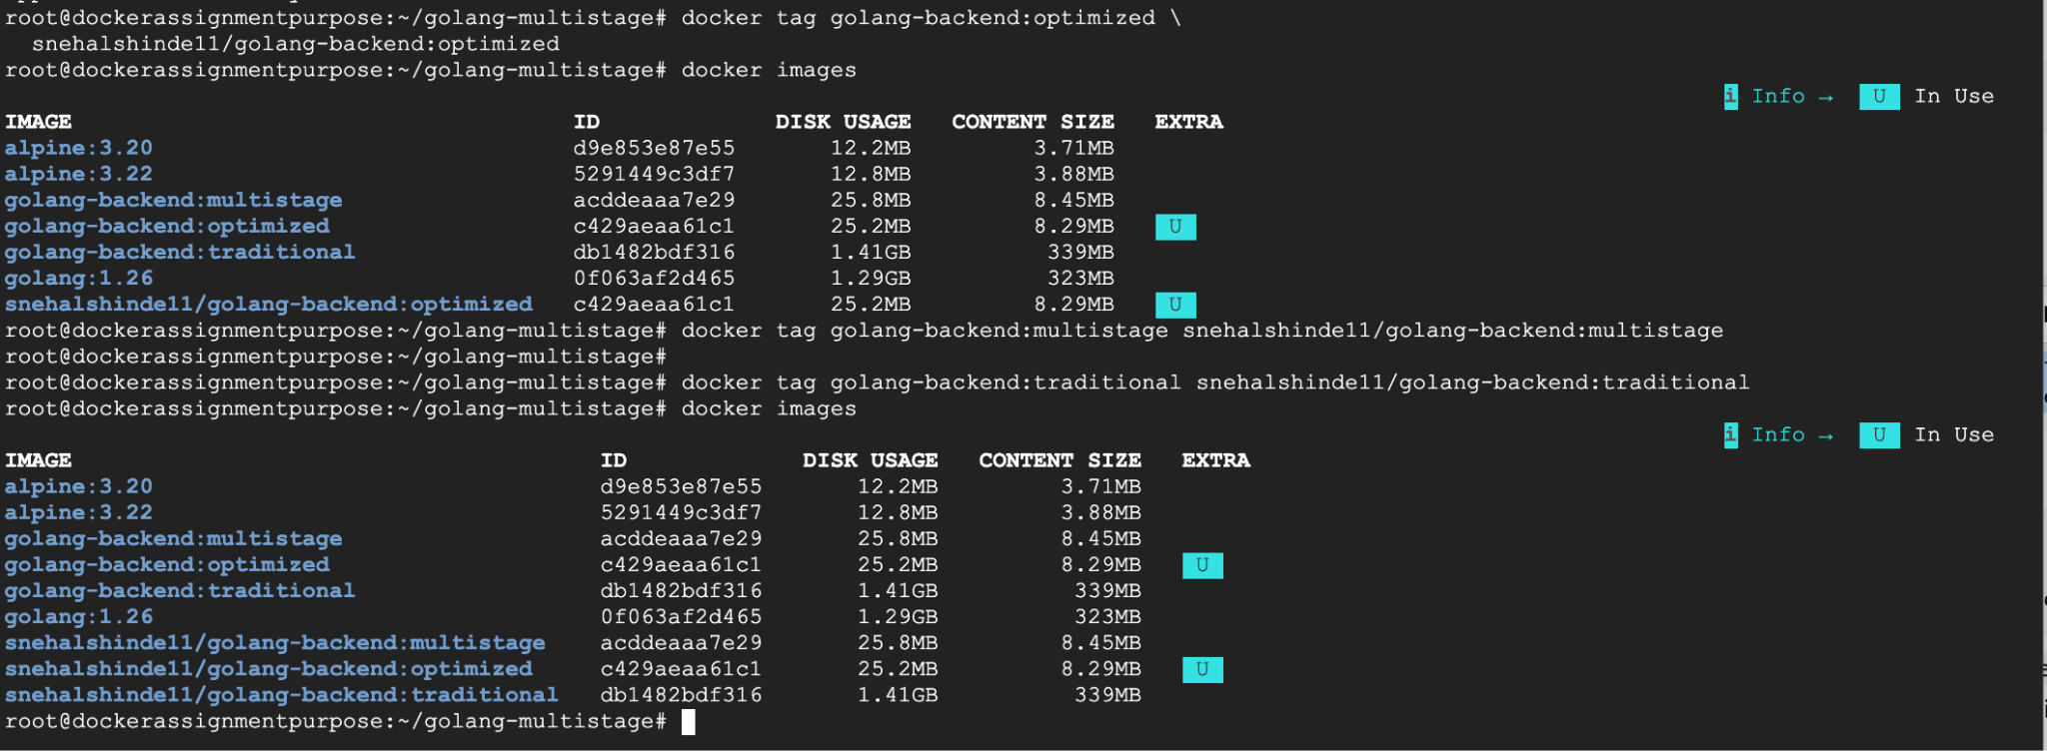
#docker login
#docker push snehalshinde11/golang-backend:multistage
#docker push snehalshinde11/golang-backend:optimized
#docker push snehalshinde11/golang-backend:traditional

